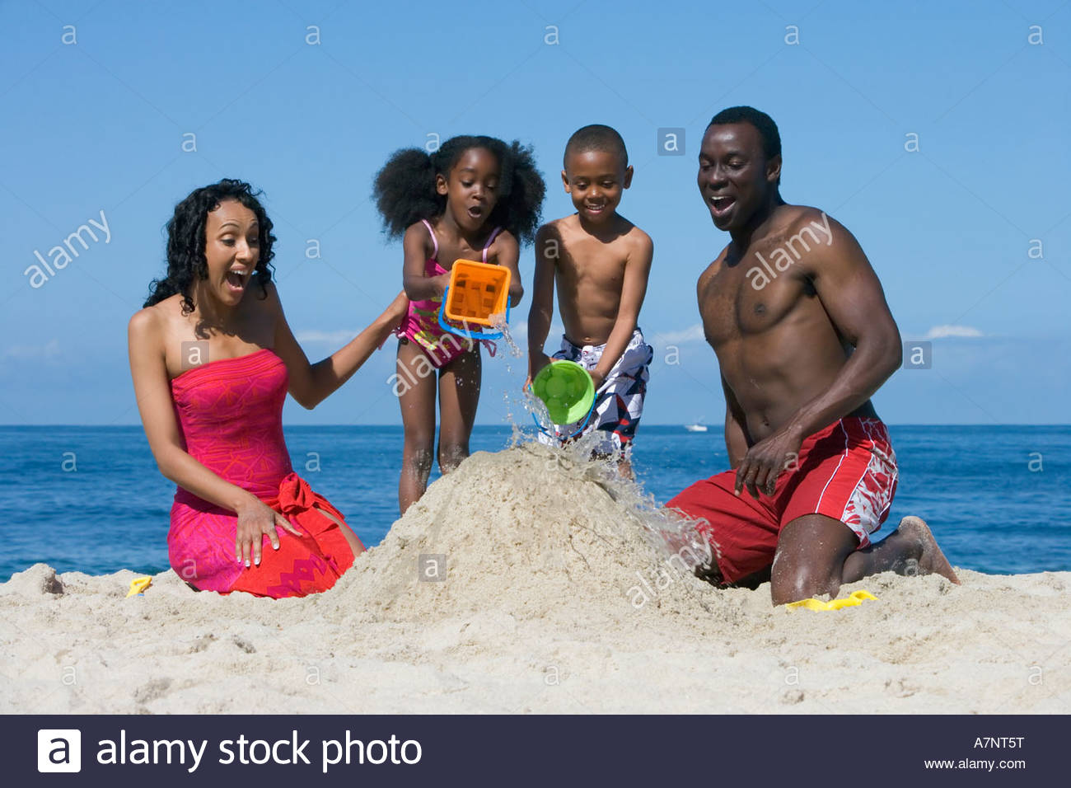

**Summer Reading Group Project**

(exactly this exciting)

**Wednesday, August 28**, you and your group will be presenting on one of the stories in the book that you read over the summer. Your presentation should include:

* Summary of the main conflict **DEFINITIONS OF MAIN ELEMENTS**

|  |  |
| --- | --- |
| Exposition |  |
| Rising Action |  |
| Climax |  |
| Falling Action |  |
| Resolution |  |

* + Describe the main characters (include basic information such as approximate age, gender, family/friend relationships, and some information about their personality)

Your grade will include:

* The attached outline of the information above
  + Each person in the group needs to turn in one of these.
* Verbal presentation (can we hear you, are you talking to the floor, is every other word “uuuuuuhhh”, **does everyone participate**, etc)
* Peer evaluation form

**Story title: ____________________________________________________________**

Main conflict (What overall problem do(es) the main character(s) face? This should be 1-2 sentences). __________________________________________________________________________________________

__________________________________________________________________________________________

__________________________________________________________________________________________

__________________________________________________________________________________________

__________________________________________________________________________________________

|  |  |
| --- | --- |
| Exposition |  |
| Rising Action  **(include at least 2 points)** |  |
| Climax |  |
| Falling Action |  |
| Resolution |  |

|  |  |
| --- | --- |
| Character name | Description |
|  |  |
|  |  |

1. How is the main character’s disability both a challenge and a strength? __________________________

__________________________________________________________________________________________

__________________________________________________________________________________________

__________________________________________________________________________________________

__________________________________________________________________________________________

__________________________________________________________________________________________

__________________________________________________________________________________________

**BUT WAIT! THERE IS ONE MORE QUESTION ON THE BACK!**

**YOU READ MY NOTE! WAY TO GO, BOSS!**

1. Compare and contrast the main character’s feelings about their ability level to how others react to their ability level. _________________________________________________________________________

__________________________________________________________________________________________

__________________________________________________________________________________________

__________________________________________________________________________________________

__________________________________________________________________________________________

__________________________________________________________________________________________

__________________________________________________________________________________________

__________________________________________________________________________________________

__________________________________________________________________________________________